CPEG 207 Digital Systems HOMEWORK 6
Name: _______________________________________________
Show your work detail and clearly identify your answer.
- A) When a LOW is on the output of each of the decoding gates, what is the binary code appearing on the inputs? The MSB is A3.
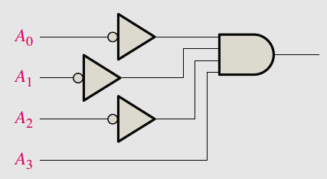
B) If the input waveforms are applied to the decoding logic as indicated, sketch the
output waveform in proper relation to the inputs.
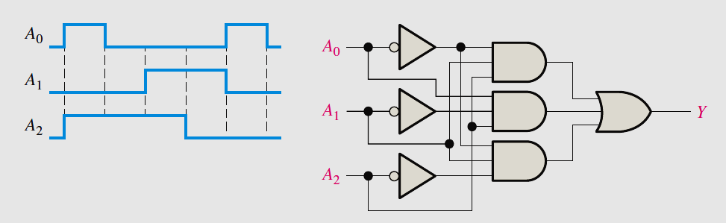
- A) A 7-segment decoder/driver drives the display. If the waveforms are applied as
indicated, determine the sequence of digits that appears on the display.
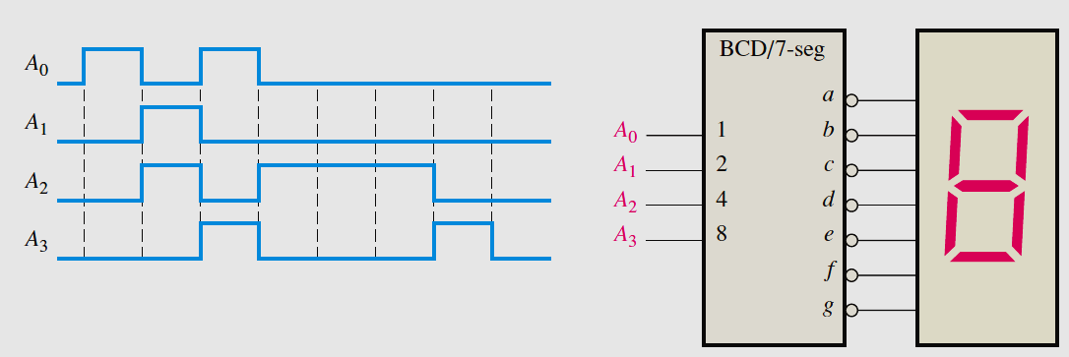

B) For the decimal-to-BCD encoder logic of Figure 6–37, assume that the 9 input and the
3 input are both HIGH. What is the output code? Is it a valid BCD (8421) code?
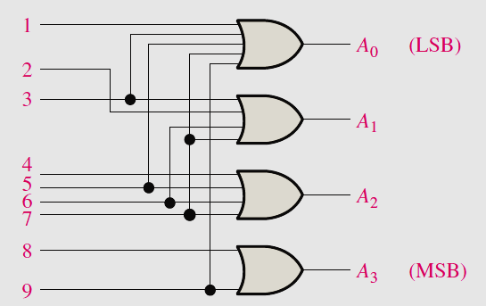
3. If the data-select inputs to the multiplexer are sequenced as shown by the waveforms,
determine the output waveform Y with the data inputs specified:
D0 = 0, D1 = 1, D2 = 1, D3 = 0
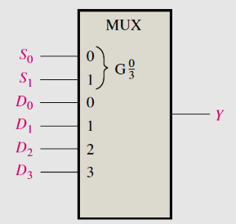 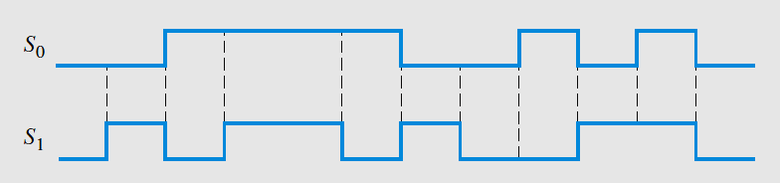

4. Implement the logic function specified in Table 6–14 by using a 74HC151 data selector.
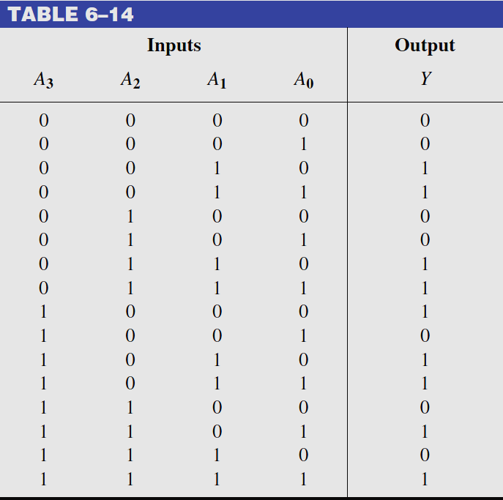 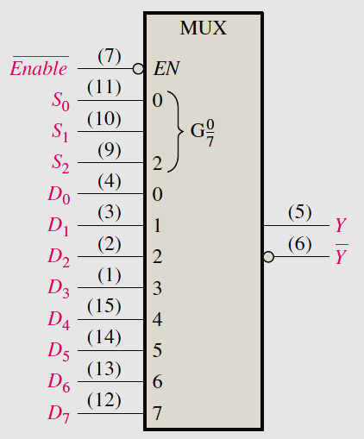
5. The serial data-input waveform (Data in) and data-select inputs (S₀ and S₁) are shown. Determine the data-output waveforms on D0 through D3 for the 1-line-to-4-lines demultiplexer.
